**Prectical no-1**

**Aim: Write about cable,hub,switch,router,bridge.**

**Cable:-**

To connect two or more computers or networking devices in a network, network cables are used. There are three types of network cables;

1. **coaxial**
2. **twisted-pair**
3. **and fiber-optic.**

**Coaxial cable**

* This cable contains a conductor, insulator, braiding, and sheath. The sheath covers the braiding, the braiding covers the insulation, and the insulation covers the conductor.

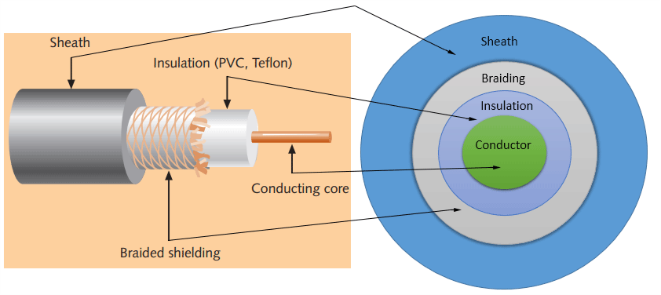

**Coaxial Cable**

#### Sheath

This is the outer layer of the coaxial cable. It protects the cable from physical damage.

#### Braided shield

This shield protects signals from external interference and noise. This shield is built from the same metal that is used to build the core.

#### Insulation

Insulation protects the core. It also keeps the core separate from the braided shield. Since both the core and the braided shield use the same metal, without this layer, they will touch each other and create a short-circuit in the wire.

#### Conductor

The conductor carries electromagnetic signals. Based on conductor a coaxial cable can be categorized into two types; single-core coaxial cable and multi-core coaxial cable.

* A **single-core** coaxial cable uses a single central metal (usually copper) conductor, while a **multi-core** coaxial cable uses multiple thin strands of metal wires. 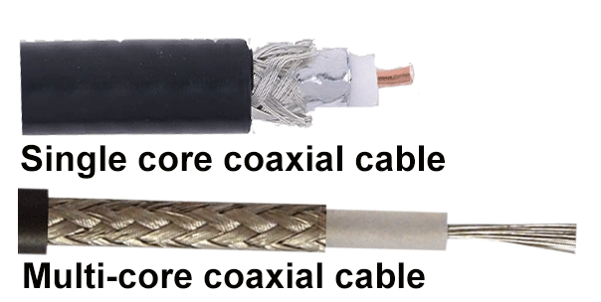

**Coaxial Cable type**

## Twisted-pair cables

The twisted-pair cable was primarily developed for computer networks. This cable is also known as **Ethernet cable**. Almost all modern LAN computer networks use this cable.

This cable consists of color-coded pairs of insulated copper wires. Every two wires are twisted around each other to form pair. Usually, there are four pairs. Each pair has one solid color and one stripped color wire. Solid colors are blue, brown, green, and orange. In stripped color, the solid color is mixed with the white color.

Based on how pairs are stripped in the plastic sheath, there are two types of twisted-pair cable; UTP and STP.

In the **UTP (*Unshielded twisted-pair*) cable**, all pairs are wrapped in a single plastic sheath.

In the **STP (*Shielded twisted-pair*) cable**, each pair is wrapped with an additional metal shield, then all pairs are wrapped in a single outer plastic sheath.

### Differences between STP and UTP cables.

* Both STP and UTP can transmit data at 10Mbps, 100Mbps, 1Gbps, and 10Gbps.
* Since the STP cable contains more materials, it is more expensive than the UTP cable.
* Both cables use the same RJ-45 (registered jack) modular connectors.
* The STP provides more noise and EMI resistance than the UTP cable.
* The maximum segment length for both cables is 100 meters or 328 feet.
* Both cables can accommodate a maximum of 1024 nodes in each segment.

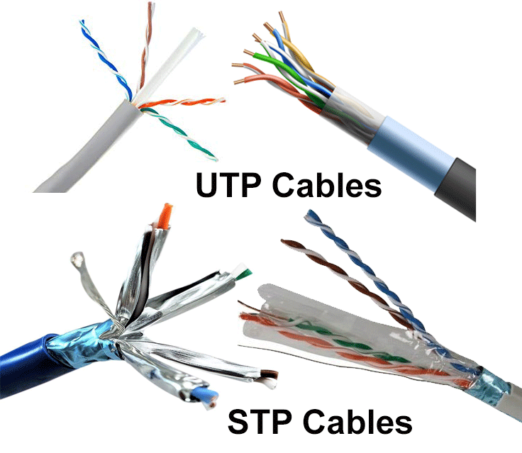

Fiber optic cable

This cable consists of a core, cladding, buffer, and jacket. The core is made from thin strands of glass or plastic that can carry data over a long distance. The core is wrapped in the cladding; the cladding is wrapped in the buffer, and the buffer is wrapped in the jacket.

* Core carries the data signals in the form of light.
* Cladding reflects light back to the core.
* Buffer protects the light from leaking.
* The jacket protects the cable from physical damage.

It can transmit data up to 40 kilometers at the speed of 100Gbps. Fiber optic uses light to send data. It reflects light from one endpoint to another.

Two types of fiber optical cable;

1. SMF
2. MMF

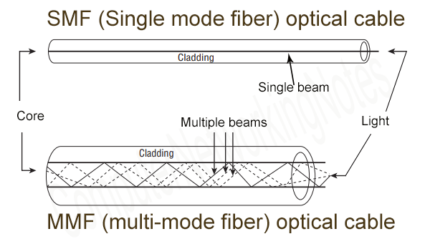

**SMF & MMF**

### SMF (Single-mode fiber) optical cable

This cable carries only a single beam of light. This is more reliable and supports much higher bandwidth and longer distances than the MMF cable.

This cable uses a laser as the light source and transmits 1300 or 1550 nano-meter wavelengths of light.

### MMF (multi-mode fiber) optical cable

This cable carries multiple beams of light. Because of multiple beams, this cable carries much more data than the SMF cable.

 This cable is used for shorter distances. This cable uses an LED as the light source and transmits 850 or 1300 nano-meter wavelengths of light.

**Hub:**

A **hub** is the most basic networking [device](https://www.computerhope.com/jargon/d/device.htm) that connects multiple computers or other network devices together.

Unlike a network [switch](https://www.computerhope.com/jargon/s/switch.htm) or [router](https://www.computerhope.com/jargon/r/router.htm), a network hub has no [routing tables](https://www.computerhope.com/jargon/r/routing_table.htm) or intelligence on where to send information and [broadcasts](https://www.computerhope.com/jargon/b/broadcas.htm) all network data across each connection.

Most hubs can detect basic network errors, such as [collisions](https://www.computerhope.com/jargon/c/collisio.htm),

network hubs were popular because they were cheaper than a switch or router.

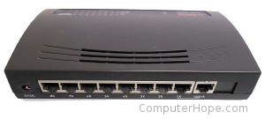

**Hub**

a hub refers to a [hardware](https://www.computerhope.com/jargon/h/hardware.htm) device that enables multiple devices or connections to connect to a computer.

An example is a **USB hub**, which allows multiple [USB devices](https://www.computerhope.com/jargon/u/usb.htm) to connect to one computer, even though that computer may only have a few USB connections.

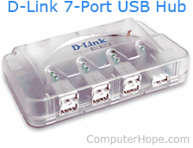

**Usb Hub**

**Switch**

it may refer to part of the physical circuit components that control the flow of signals. It can be a button or lever to turn a device on or off.

a switch is a hardware device that filters and forwards network packets from one networking device (switch, router, computer, server, etc.) to another.

It is widely used in local area networks (LANs) to send each incoming message frame by looking at the physical device address, known as the Media Access Control address (MAC address).

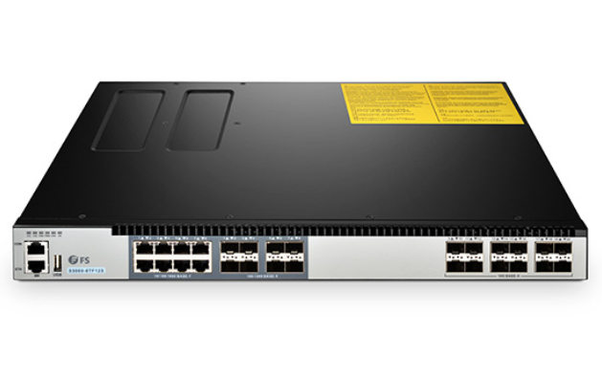

**Switch**

A switch is considered as a multiport network bridge that uses hardware addresses to process and forward data at the data link layer (layer 2) of the OSI model.

Router:-

A router is a physical or [virtual appliance](https://searchservervirtualization.techtarget.com/definition/virtual-appliance) that passes information between two or more packet-switched computer networks. A router inspects a given data [packet](https://www.techtarget.com/searchnetworking/definition/packet-loss)'s destination Internet Protocol address (IP address), calculates the best way for it to reach its destination and then forwards it accordingly.

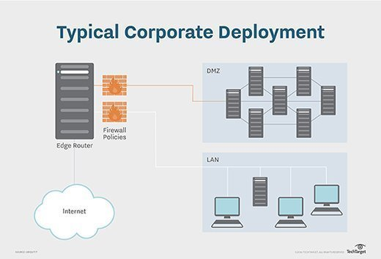

A router is a common type of [gateway](https://internetofthingsagenda.techtarget.com/definition/gateway). It is positioned where two or more networks meet at each [point of presence](https://www.techtarget.com/searchnetworking/definition/point-of-presence-POP) on the internet.

Bridge:-

Bridges are networking devices that connect networks. Sometimes it is necessary to divide networks into subnets to reduce the amount of traffic on each larger subnet or for security reasons. Once divided, the bridge connects the two subnets and manages the traffic flow between them. Today, network switches have largely replaced bridges.

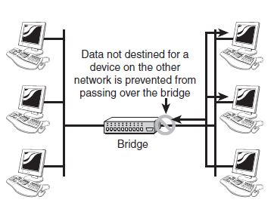

The advantages of bridges are simple and significant. By preventing unnecessary traffic from crossing onto other network segments, a bridge can dramatically reduce the amount of network traffic on a segment. Bridges also make it possible to isolate a busy network from a not-so-busy one, thereby preventing pollution from busy nodes.

**Prectical no-2**

**Aim: Write about ping, ns lookup.**

**Ping:-**

A ping (Packet Internet or Inter-Network Groper) is a basic [Internet](https://whatis.techtarget.com/definition/Internet) program that allows a user to test and verify if a particular destination [IP address](https://whatis.techtarget.com/definition/IP-address) exists and can accept requests in computer network administration.

The term is also used to test and determine how fast a data [signal](https://www.techtarget.com/searchnetworking/definition/signal) travels from one place, like a computer, to another, like a website. Ping is also used to [troubleshoot](https://whatis.techtarget.com/definition/troubleshooting) and test connectivity and determine response time.

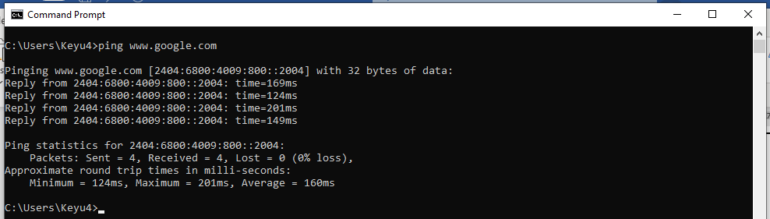

**ns lookup:-**

nslookup is the name of a program that lets an Internet server administrator or any computer user enter a host name (for example, "whatis.com") and find out the corresponding IP address or domain name system (DNS) record.

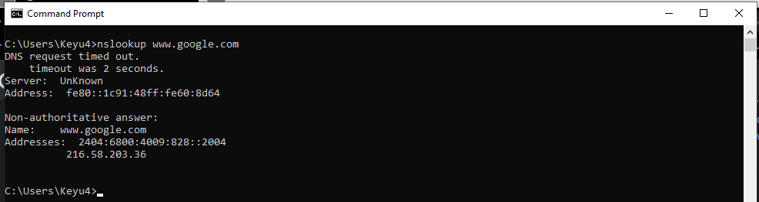

**Prectical no-3**

**Aim: Write about ipconfig, arp, netstat, tracert, telnet.**

**Ipconfig:-**

(**I**nternet **P**rotocol**CONFIG**uration) A command line utility that is used to display and manage the IP address assigned to the machine. In Windows, typing **ipconfig** without any parameters displays the computer's currently assigned IP, subnet mask and default gateway addresses.

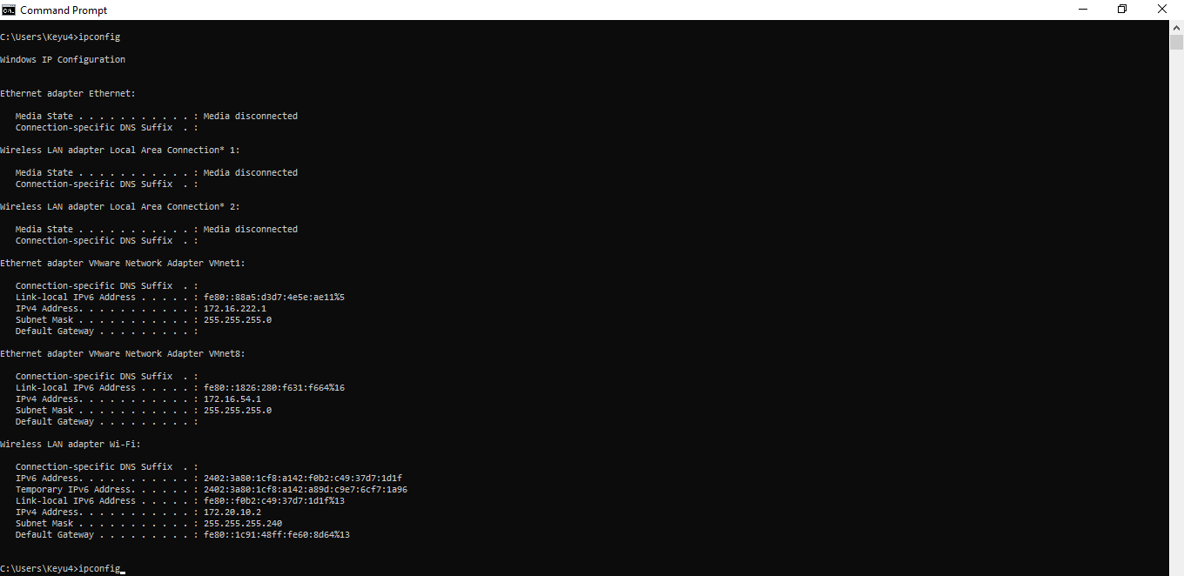

**Netstat:-**

Netstat — derived from the words network and statistics — is a program that’s controlled via commands issued in the command line. It delivers basic statistics on all network activities and informs users on which **portsand addresses** the corresponding connections (TCP, UDP) are running and which ports are open for tasks.

|  |  |
| --- | --- |
| **Command** | **Description** |
| netstat | Standard listing of all active connections |
| netstat -a | Displays all active ports |
| netstat -b | Displays the executable file of a connection or listening port (requires administrator rights) |
| netstat -e | Shows statistics about your network connection (received and sent data packets, etc.) |

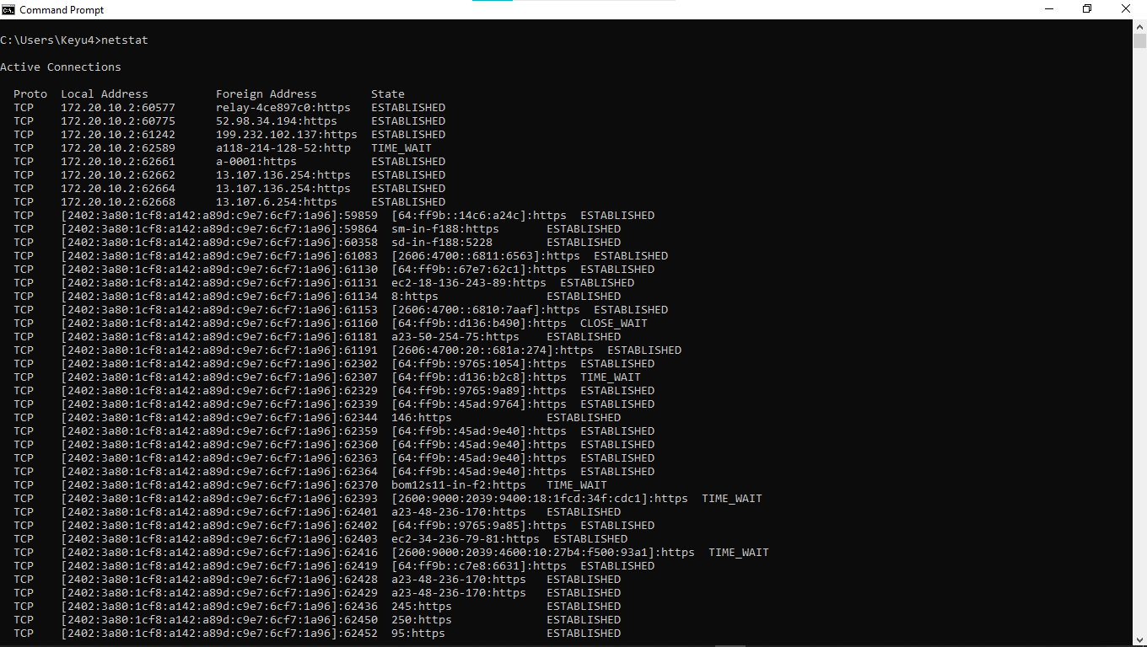

**Tracert:-**

The Traceroute command (tracert) is a utility designed for displaying the time it takes for a packet of information to travel between a local computer and a destination IP address or domain.

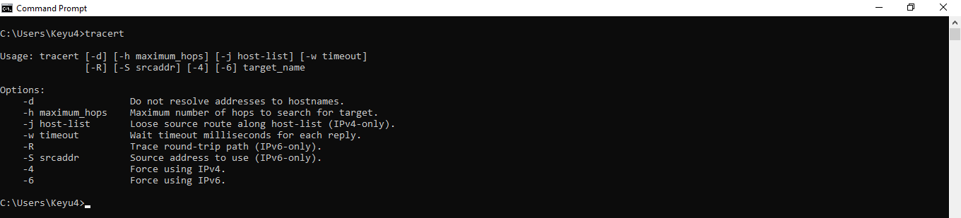

**Telnet:-**

Telnet, developed in 1969, is a protocol that provides a command line interface for communication with a remote device or server, sometimes employed for remote management but also for initial device setup like network hardware. Telnet stands for Teletype Network, but it can also be used as a verb; 'to telnet' is to establish a connection using the Telnet protocol.

**Prectical no-4a**

**Aim: Implement a simple TCP socket based client server program in Python in which the client connects to the server. The server displays the ip address and port number of client and sends an acknowledgement message back to client. The client displays the received acknowledgement message on screen.**

**Client:-**

import socket

host = '127.0.0.1'

port=9005

#create client side socket

s = socket.socket()

s.connect((host,port))

#enter data at client

str = input("Enter Data: ")

# continue as long as exit not entered by user

while str != 'bye' :

#send data from client to server

s.send(str.encode())

# receive the response data from server

data = s.recv(1024)

data = data.decode()

print("From Server :" +data)

#enter data

str = input("Enter Data : ")

#close connection

s.close()

**Server:-**

import socket

host = '127.0.0.1'

port=9005

#create server side socket

s = socket.socket()

s.bind((host,port))

#let maximum number of connections are 1 only

s.listen(1)

# wait till a client connects

c, addr = s.accept()

print("A Client Connected")

#server runs continuously

while True:

#receive data from client

data=c.recv(1024)

# if client sends empty strings, come out

if not data:

break

print("From Client :" +str(data.decode()))

# send the response data to client

#enter data at client

str1 = input("Enter Data sender: ")

c.send(str1.encode())

# close connection

c.close()

**Output:-**

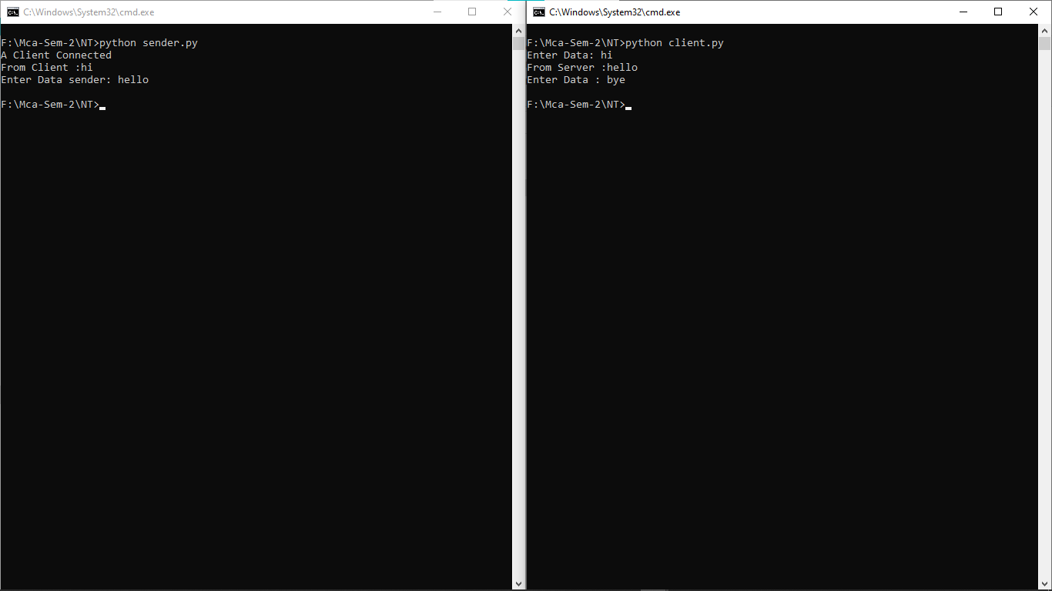

**Prectical no-4b**

**Aim: Implement a simple UDP socket based client server program in Python in which the client connects to the server. The server displays the ip address and port number of client and sends an acknowledgement message back to client. The client displays the received acknowledgement message on screen.**

**Sender:-**

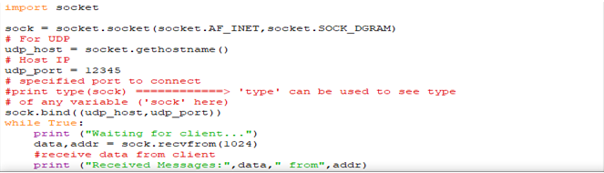

**Client:-**

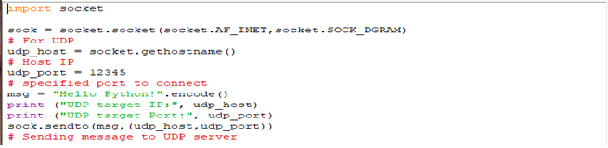

**Output:-**

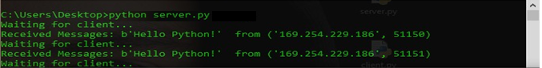

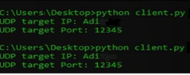

**Prectical no-5**

**Aim: Wireshark Installation, understanding the Wireshark Environment / Menu System, to start and stop live capture of traffic from given wired Ethernet network interface, capturing options, store captured data in different supported file formats, to open already stored captured data file.**

**Wireshark :-**

**Wireshark** is a network [packet](https://www.computerhope.com/jargon/p/packet.htm) analyzer used for capturing ([sniffing](https://www.computerhope.com/jargon/s/sniffing.htm)) packets flowing across a computer network in addition to those that are moving to and from your computer.

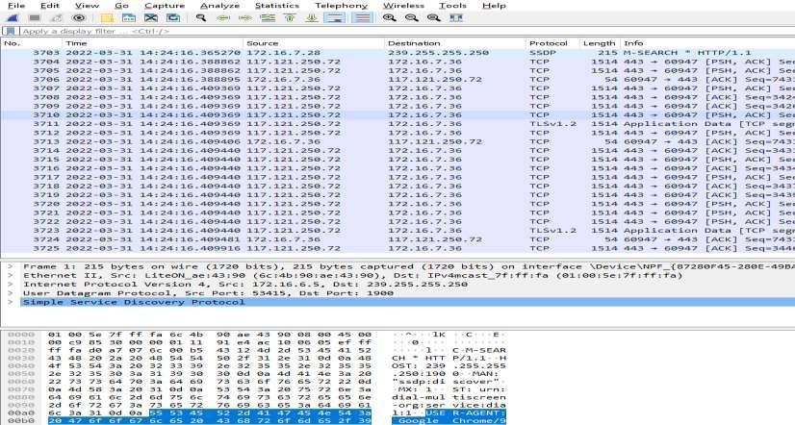

Wireshark is the most often-used packet sniffer in the world. Like any other packet sniffer, Wireshark does three things:

## 1.Packet Capture:

Wireshark listens to a network connection in real time and then grabs entire streams of traffic – quite possibly tens of thousands of packets at a time.

## Filtering:

Wireshark is capable of slicing and dicing all of this random live data using filters. By applying a filter, you can obtain just the information you need to see.

## Visualization:

Wireshark, like any good packet sniffer, allows you to dive right into the very middle of a network packet. It also allows you to visualize entire conversations and network streams.

**How to use wireshark**

If you find yourself troubleshooting network issues, and you have to inspect individual packets, you need to use Wireshark.

**Prectical no-6**

**Aim:** **Learn and use view level filters and capture level filters in Wireshark for different traffic types like Ethernet, ARP, IP, TCP, UDP, DNS, HTTP, etc. For each captured category, observe how different headers are encapsulated within each other. E.g. TCP encapsulated within IP, HTTP encapsulated within TCP, etc**

ETHERNET

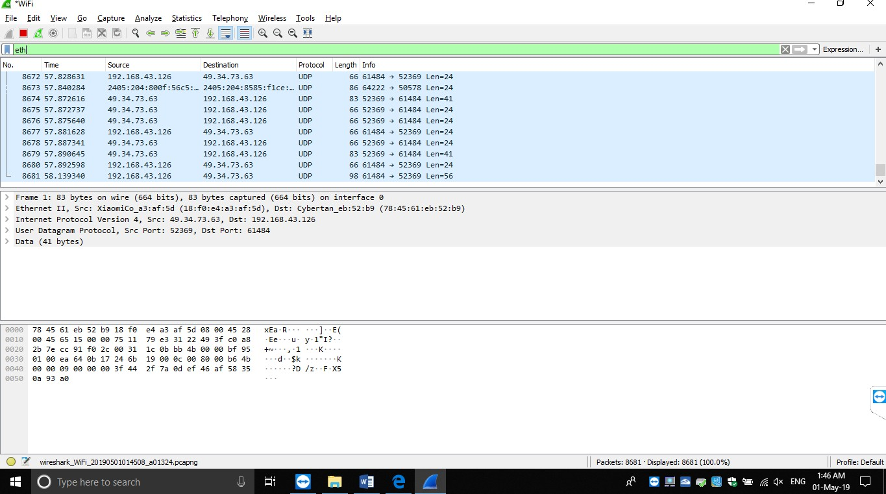

ARP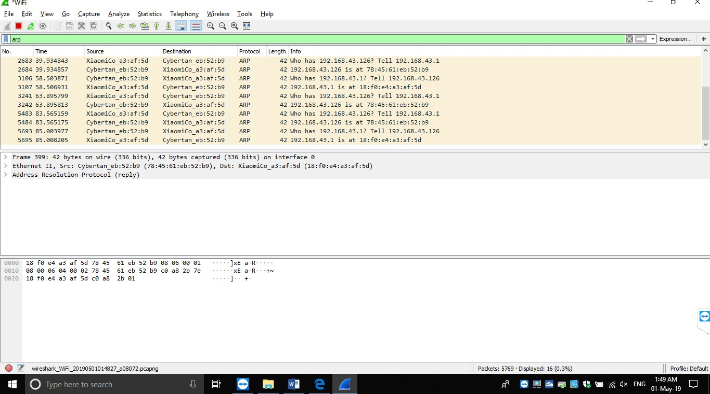

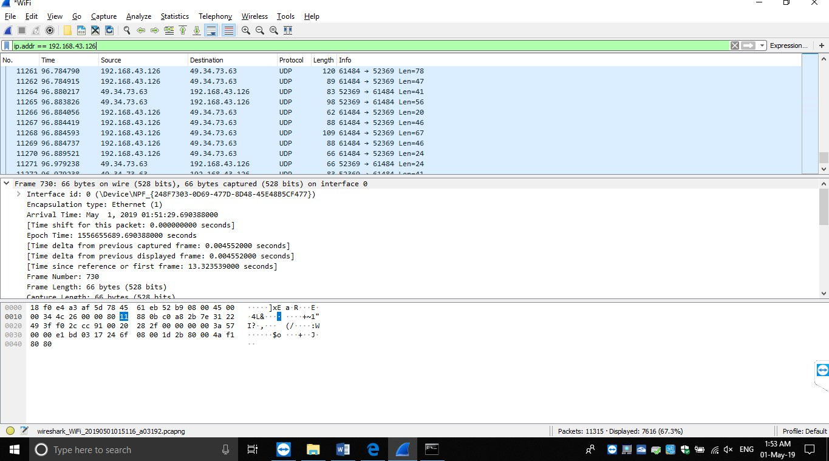IP

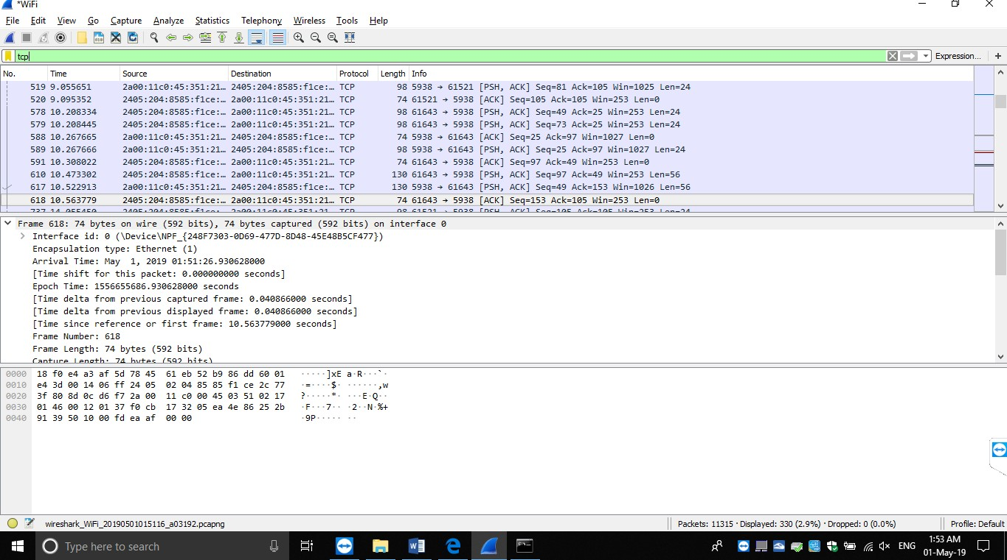TCP

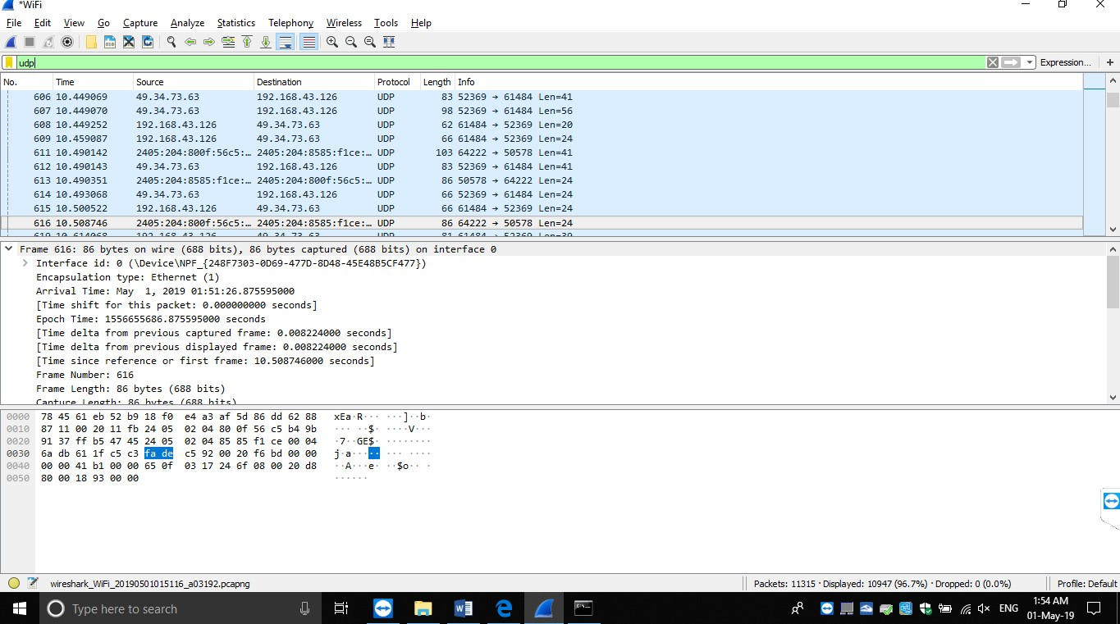UDP

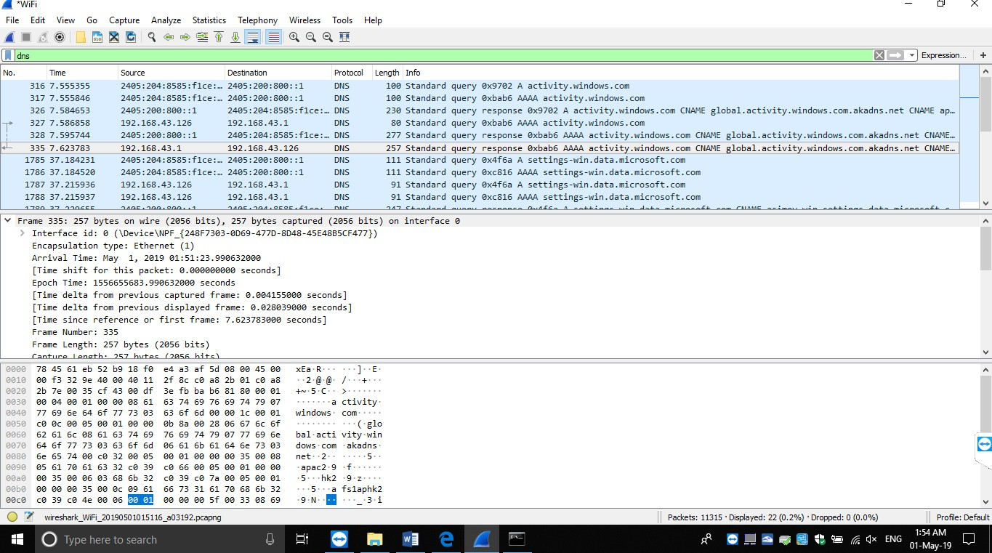DNS

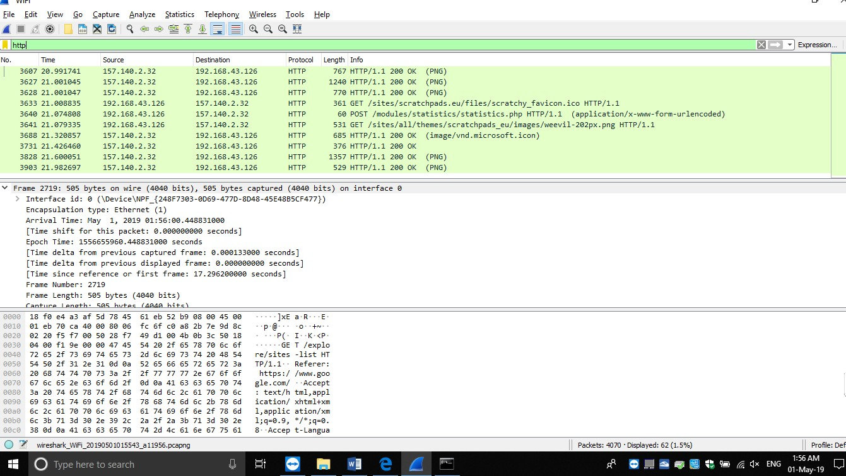HTTP

**Prectical no-7**

**AIm: Capture the following traffic types and Interpret/ Analyze the corresponding header and payload: Ethernet and ARP.**

**ARP:**

Address Resolution Protocol (ARP) is a predominant protocol for finding a host’s hardware address when only its network layer address is known.

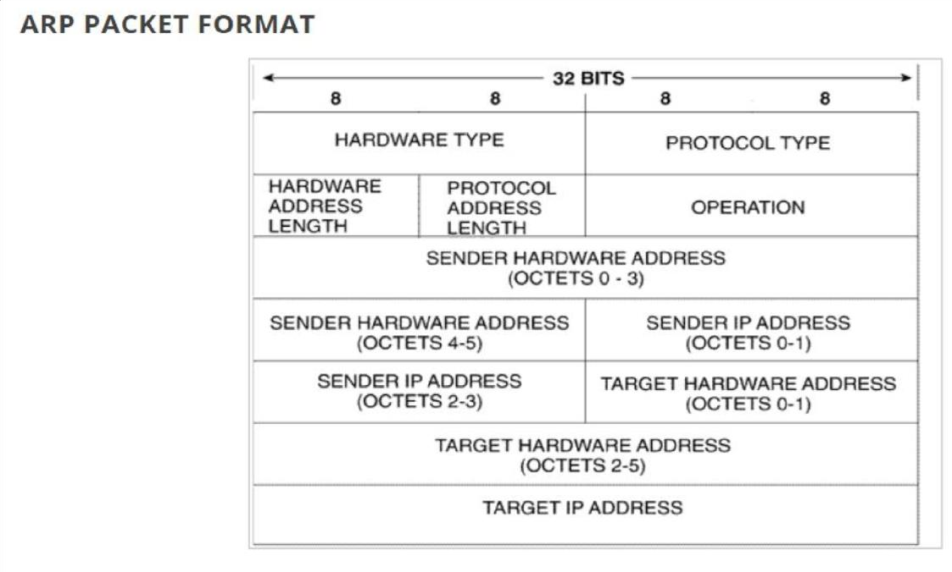

**HARDWARE TYPE: -** Each data link layer protocol is assigned a number used in this field. For Ethernet it is 1.

**PROTOCOL TYPE: -** Each protocol is assigned a number used in this field. For example, IPv4 is 0x0800. **HARDWARE LENGTH: -** Length in bytes of a hardware address. Ethernet addresses are 6 bytes long. **PROTOCOL LENGTH: -** Length in bytes of a logical address. IPv4 addresses are 4 bytes long.

**OPERATION: -** It specifies the operation the sender is performing: 1 for request, and 2 for reply. There are actually four types of ARP messages that may be sent by the ARP protocol. These are identified by four values in the “operation” field of an ARP message. The types of message are:-

1. ARP request
2. ARP reply
3. RARP request
4. RARP reply

**SENDER HARDWARE ADDRESS**: - Hardware address of the sender.

**SENDER PROTOCOL ADDRESS**: - Protocol address of the sender.

**TARGET HARDWARE ADDRESS**: - Hardware address of the intended receiver. This field is zero on request.

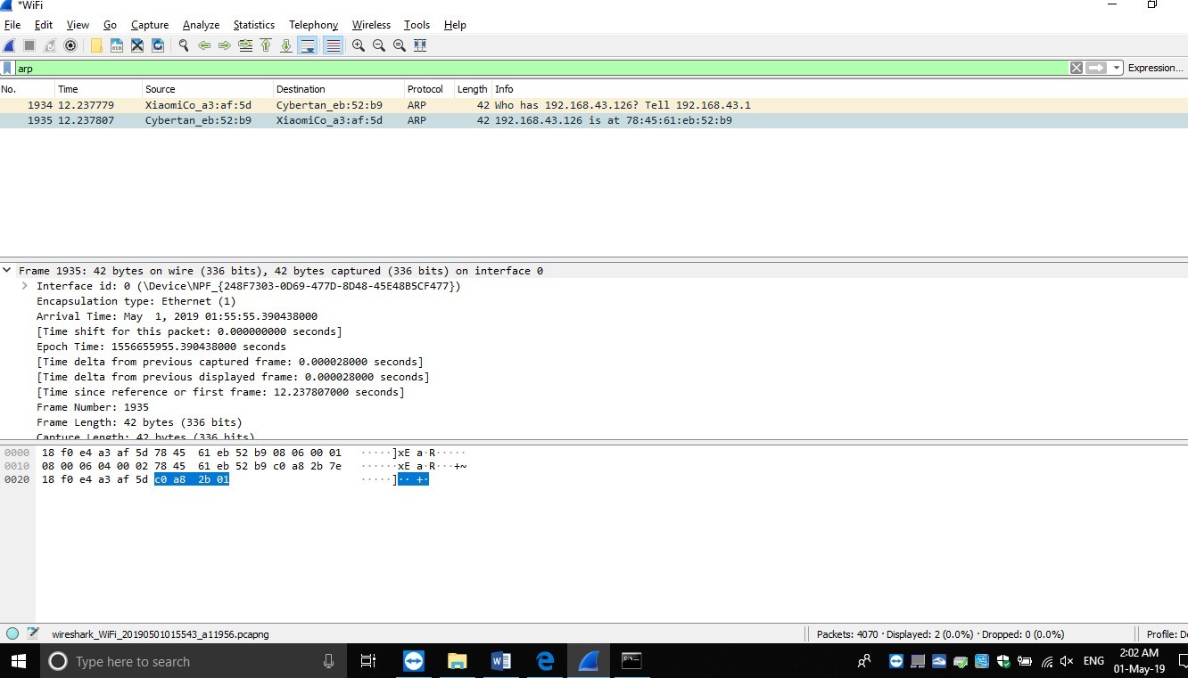**TARGET PROTOCOL ADDRESS**: - Protocol address of the intended receiver.

**Ethernet:-**

An Ethernet frame is made up of five fields: the Destination and the Source MAC address field, the Ether type field that contains some control information, a Payload field, and a trailing Frame Check Sequence field that holds a checksum for the frame. The Ethernet frame starts with preamble and start frame delimiter, followed by an Ethernet header containing MAC address of source and destination devices.

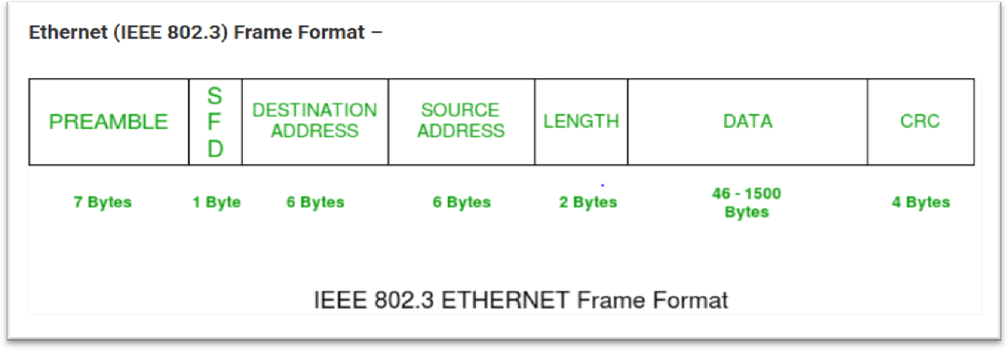

**Preamble: –** Ethernet frame starts with 7-Bytes Preamble. This is pattern of alternative 0’s and 1’s which indicates starting of the frame and allow sender and receiver to establish bit synchronization. Initially, PRE (Preamble) was introduced to allow for the loss of few bits due to signal delays.

**Start of frame delimiter (SFD): –** This is a 1-Byte field which is always set to 10101011. SFD indicates that upcoming bits are starting of frame, which is destination address. Sometimes SFD is considered the part of PRE, this is the reason Preamble is described as 8 Bytes in many places.

**Destination Address: –** This is 6-Byte field which contains the MAC address of machine for which data is destined.

**Source Address: –** This is a 6-Byte field which contains the MAC address of source machine. As Source Address is always an individual address (Unicast), the least significant bit of first byte is always 0.

**Length: –** Length is a 2-Byte field, which indicates the length of entire Ethernet frame. This 16-bit field can hold the length value between 0 and 65534, but length cannot be larger than 1500 because of some own limitations of Ethernet.

**Data: –** This is the place where actual data is inserted, also known as **Payload**. Both IP header and data will be inserted here, if Internet Protocol is used over Ethernet. The maximum data present may be as long as 1500 Bytes. In case data length is less than minimum length i.e. 46 bytes, then padding 0’s is added to meet the minimum possible length.

**Cyclic Redundancy Check (CRC): –** CRC is 4 Byte field. This field contains 32-bits hash code of data, which is generated over Destination Address, Source Address, Length and Data field. If the checksum computed by destination is not same as sent checksum value, data received is corrupted.

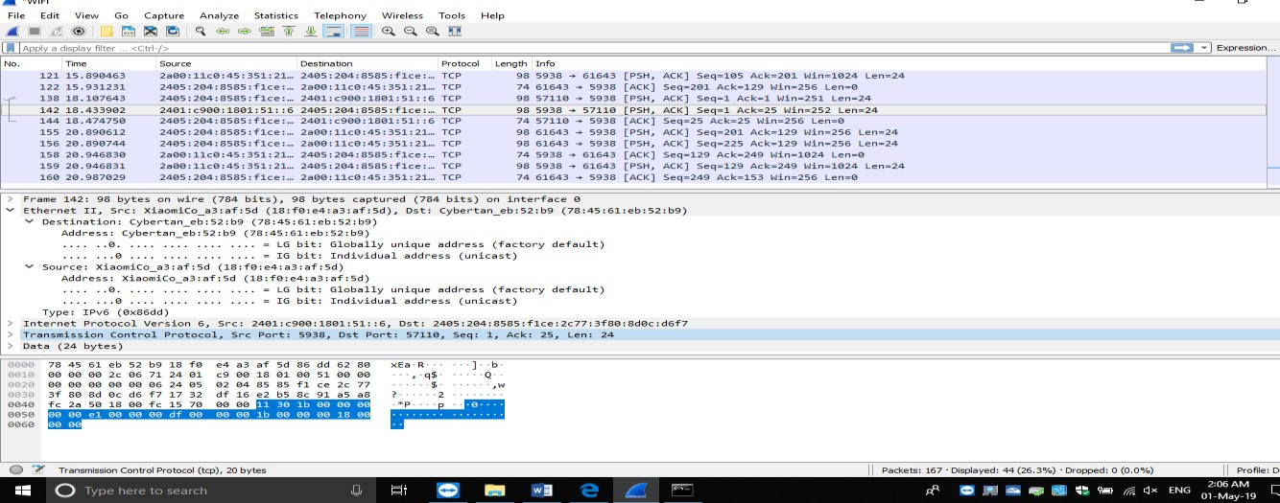

**Prectical no-8**

**Aim: Capture the following traffic types and Interpret/ Analyze the corresponding header and payload: IP and ICMP.**

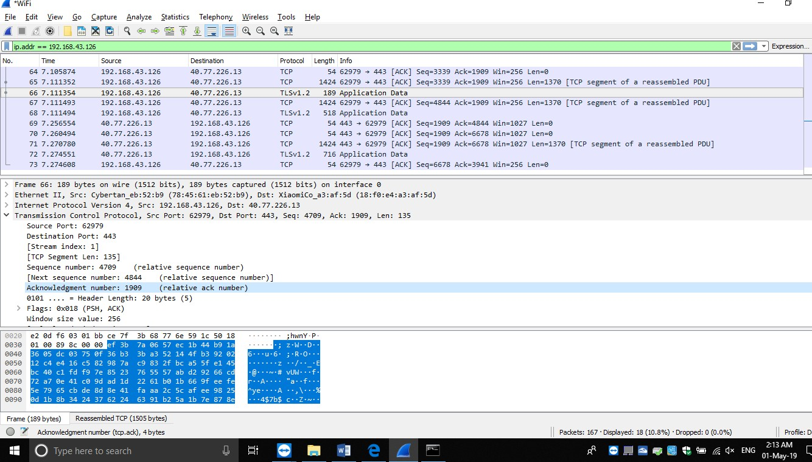IP:

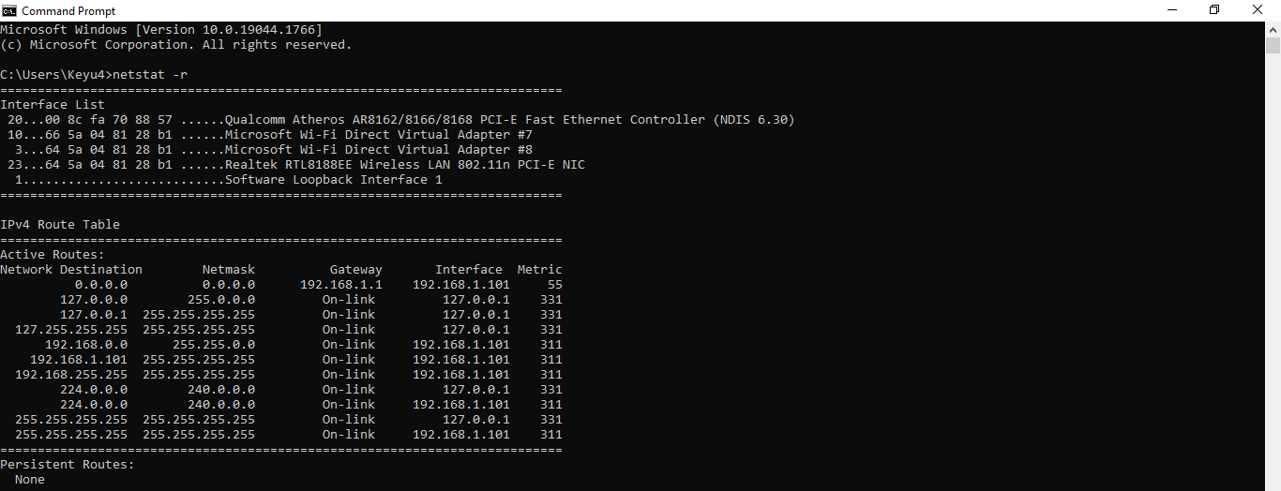

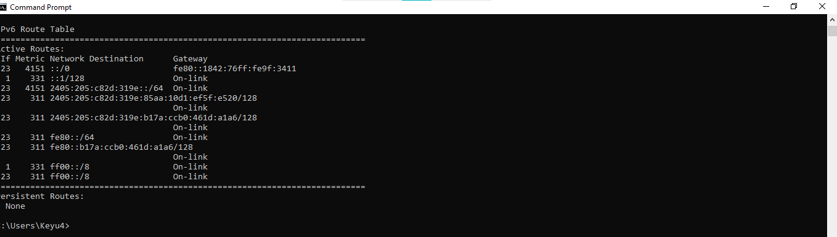

ICMP

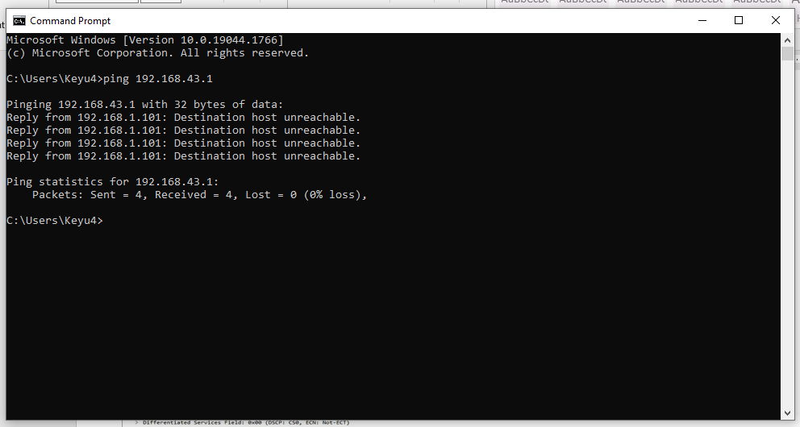

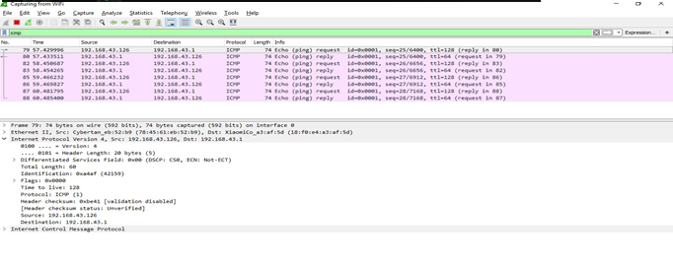

**Prectical no-9**

**Aim: Capture the following traffic types and Interpret/ Analyze the corresponding header and payload: TCP and UDP**

Header

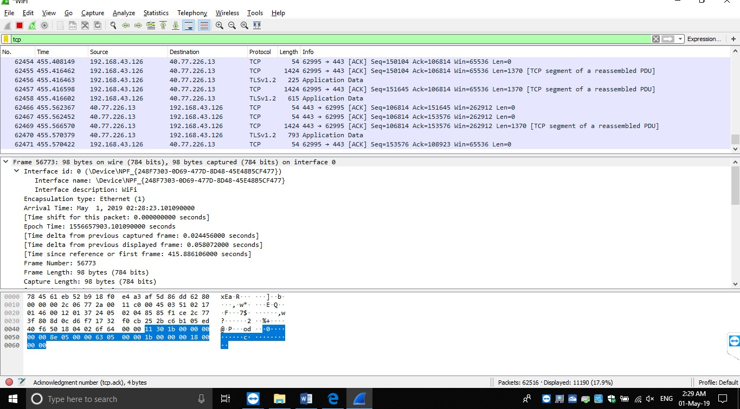

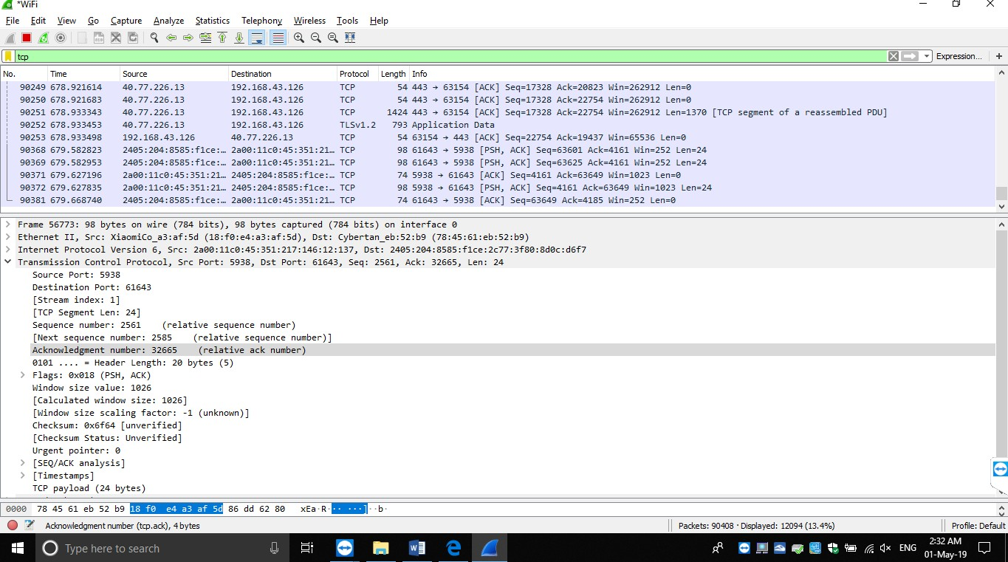PayLoad

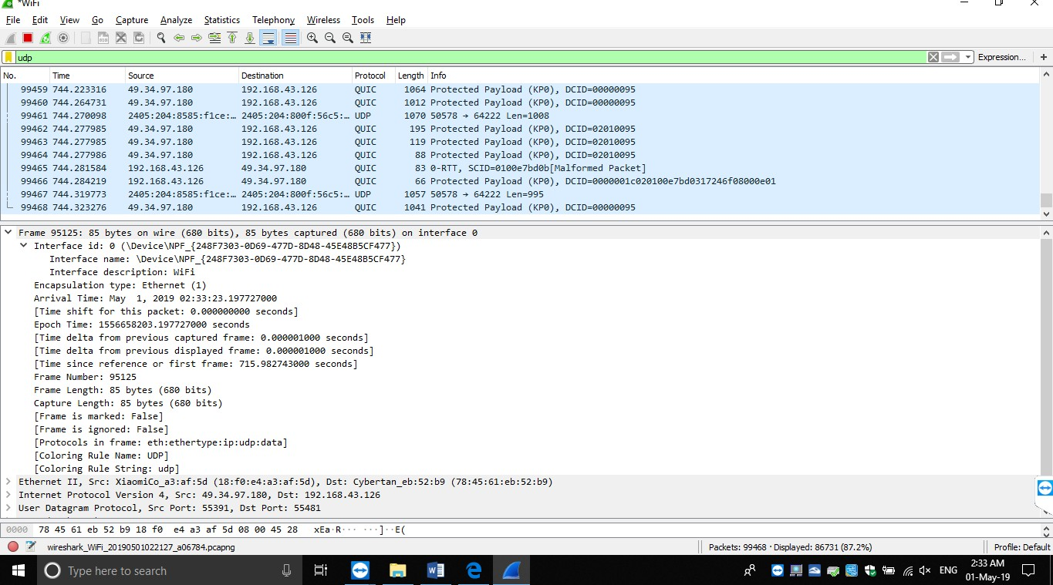UDP : Header

# PayLoad

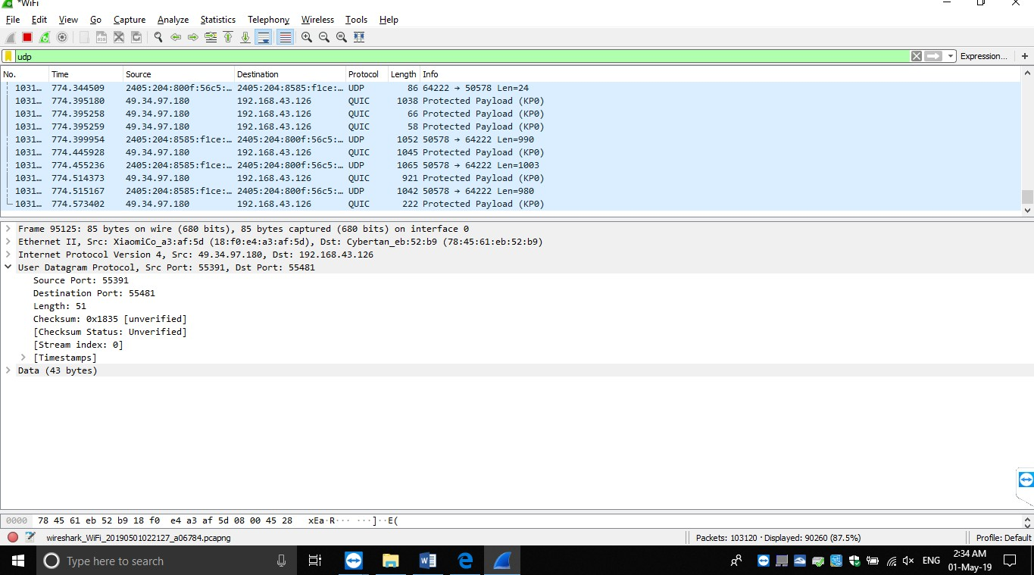

**Prectical no-10**

**Aim: Capture the following traffic types and Interpret/ Analyze the corresponding header and payload: HTTP and DNS**

**HTTP**:-

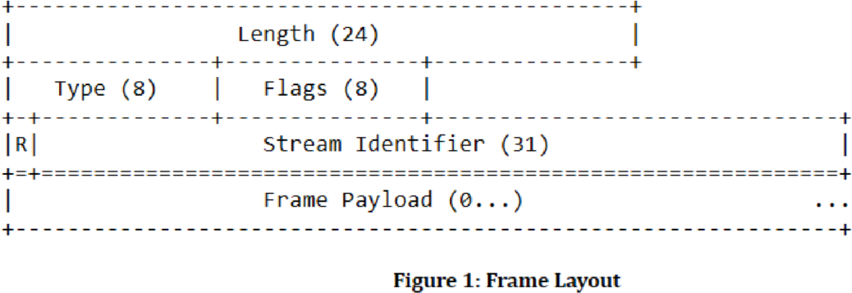The Hypertext Transfer Protocol (HTTP) is a wildly successful protocol. However, the way HTTP/1.1 uses the underlying transport has several characteristics that have a negative overall effect on application performance today. All frames begin with a fixed 9-octet header followed by a variable-length payload. Furthermore, HTTP header fields are often repetitive and verbose, causing unnecessary network traffic as well as causing the initial *TCP* congestion window to quickly fill. This can result in excessive latency when multiple requests are made on a new TCP connection.

The fields of the frame header are defined as: -

**Length**: - The length of the frame payload expressed as an unsigned 24-bit integer.

**Type**: - The 8-bit type of the frame. The frame type determines the format and semantics of the frame. Implementations MUST ignore and discard any frame that has a type that is unknown.

**Flags**: - An 8-bit field reserved for Boolean flags specific to the frame type. Flags are assigned semantics specific to the indicated frame type

**R**: - A reserved 1-bit field. The semantics of this bit are undefined, and the bit MUST remain unset (0x0) when sending and MUST be ignored when receiving.

**Stream Identifier**: - A stream identifier (see [Section 5.1.1)](https://http2.github.io/http2-spec/#StreamIdentifiers) expressed as an unsigned 31-bit integer. The value 0x0 is reserved for frames that are associated with the connection as a whole as opposed to an individual stream.

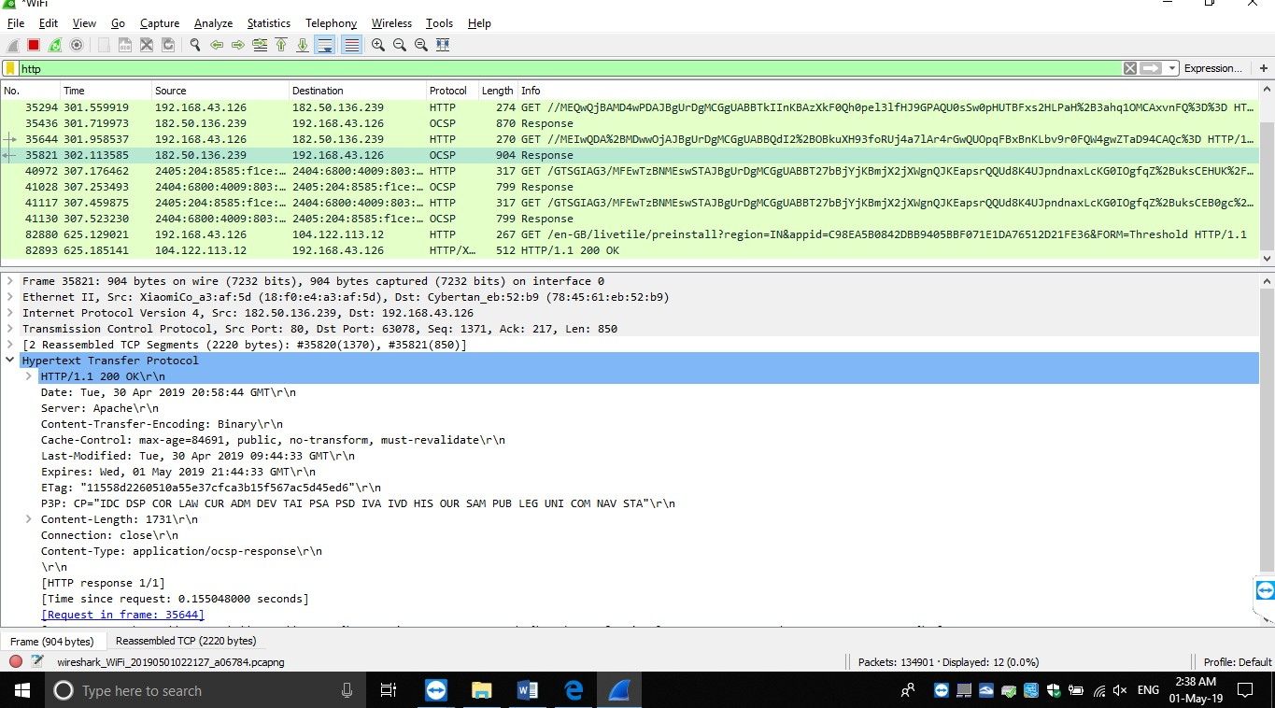

**DNS**:-

The client/server information exchange in DNS is facilitated using query/response messaging. Both

queries and responses have the same general format, containing up to five individual sections carrying information. All DNS packets have a structure that is:-

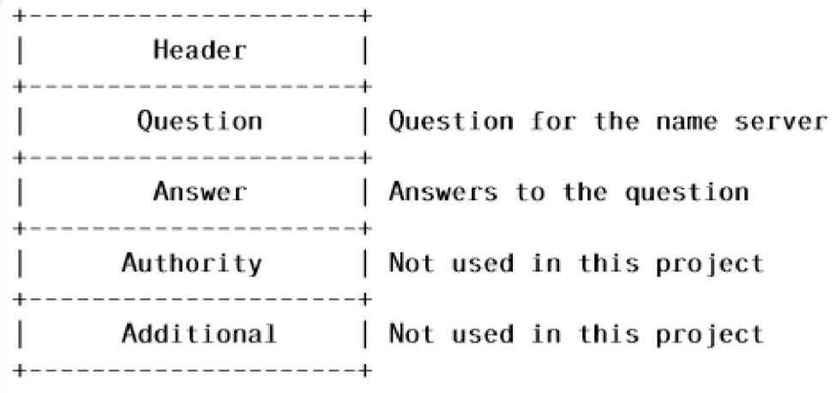

The header describes the type of packet and which fields are contained in the packet.

Following the header are a number of questions, answers, authority records, and additional records. For this project, we will be ignoring the authority and additional fields - your client program must accept packets with such fields, but must ignore them. DNS packets have a header that is shown below. Note that requests and replies follow the same header format.

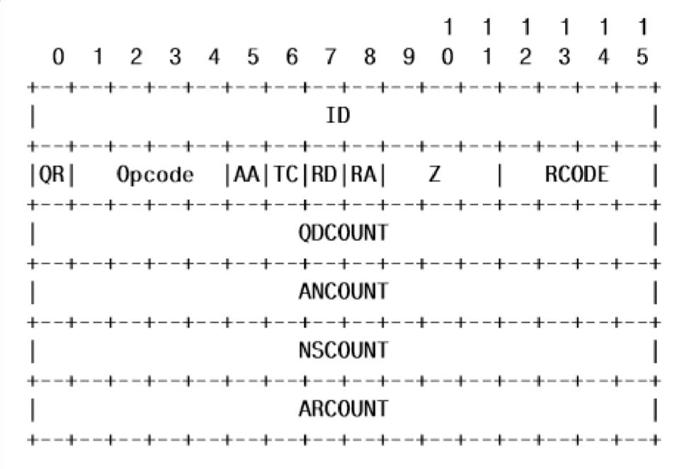

Where each of these fields is as described below:-

**ID**: - A 16 bit identifier assigned by the program that generates any kind of query. This identifier is copied the corresponding reply and can be used by the requester to match up replies to outstanding queries. You should always use 1337 for this field.

**QR**: - A one bit field that specifies whether this message is a query (0), or a response (1). Obviously, you should use 0 for your requests, and expect to see a 1 in the response you receive.

**OPCODE**: - A four bit field that specifies kind of query in this message. You should use 0, representing a standard query.

**AA Authoritative Answer**: - This bit is only meaningful in responses, and specifies that the responding name server is an authority for the domain name in question section. You should use this bit to report whether or not the response you receive is authoritative.

**TC Truncation**: - specifies that this message was truncated. Forth is project, you must exit and return an error if you receive a response that is truncated.

**RD Recursion Desired**: - this bit directs the name server to pursue the query recursively. You should use 1, representing that you desire recursion.

**RA Recursion Available**: - this be is set or cleared in a response, and denotes whether recursive query support is available in the name server. Recursive query support is optional. You must exit and return an error if you receive a response that indicates the server does not support recursion.

**Z**: - Reserved for future use. You must set this field to 0.

**RCODE Response code**: - this 4 bit field is set as part of responses. The values have the following interpretation:- 0 No error condition

1. Format error - The name server was unable to interpret the query.
2. Server failure - The name server was unable to process this query due to a problem with the name server.
3. Name Error - Meaningful only for responses from an authoritative name server, this code signifies that the domain name referenced in the query does not exist.
4. Not Implemented - The name server does not support the requested kind of query.
5. Refused - The name server refuses to perform the specified operation for policy reasons.

**QDCOUNT: -** an unsigned 16 bit integer specifying the number of entries in the question section. You should set this field to 1, indicating you have one question.

**ANCOUNT**: - an unsigned 16 bit integer specifying the number of resource records in the answer section. You should set this field to 0, indicating you are not providing any answers.

**NSCOUNT: -** an unsigned 16 bit integer specifying the number of name server resource records in the authority records section. You should set this field to 0, and should ignore any response entries in this section.

**ARCOUNT**: - an unsigned 16 bit integer specifying the number of resource records in the additional records section. You should set this field to 0, and should ignore any response entries in this section.

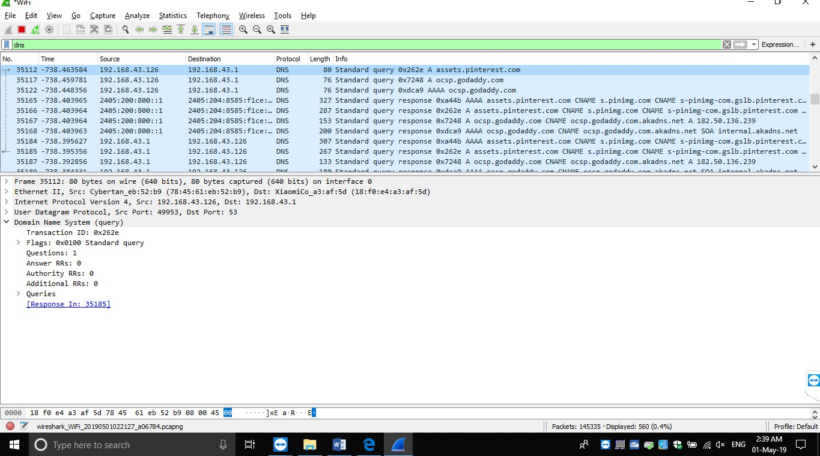

**Prectical no-11**

**Aim: Capture the following traffic types and Interpret/ Analyze the corresponding header and payload: FTP, SMTP and Telnet.**

FTP

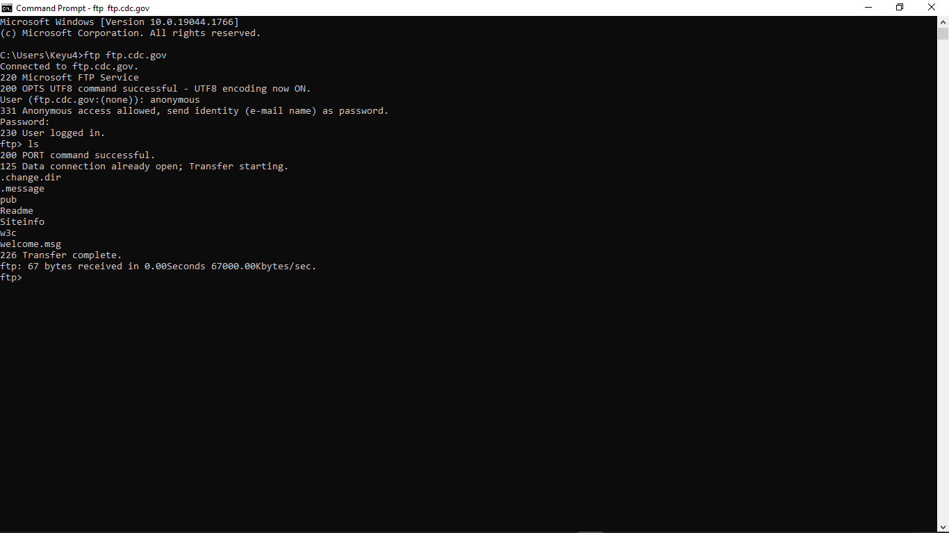

SMTP



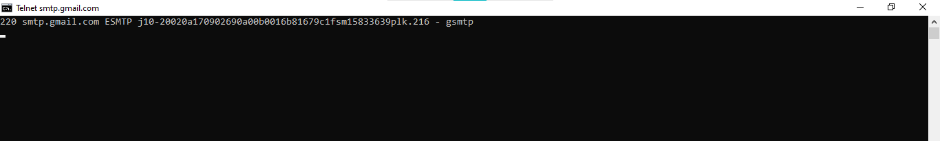

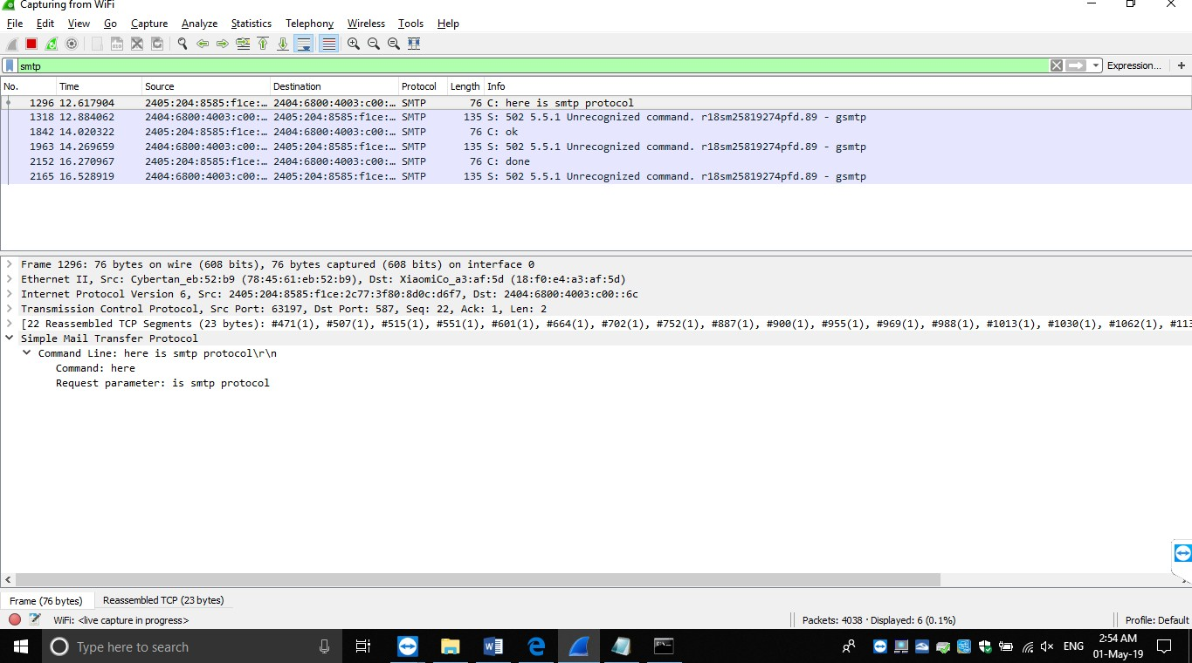

TelNet

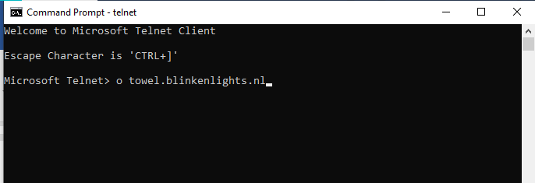

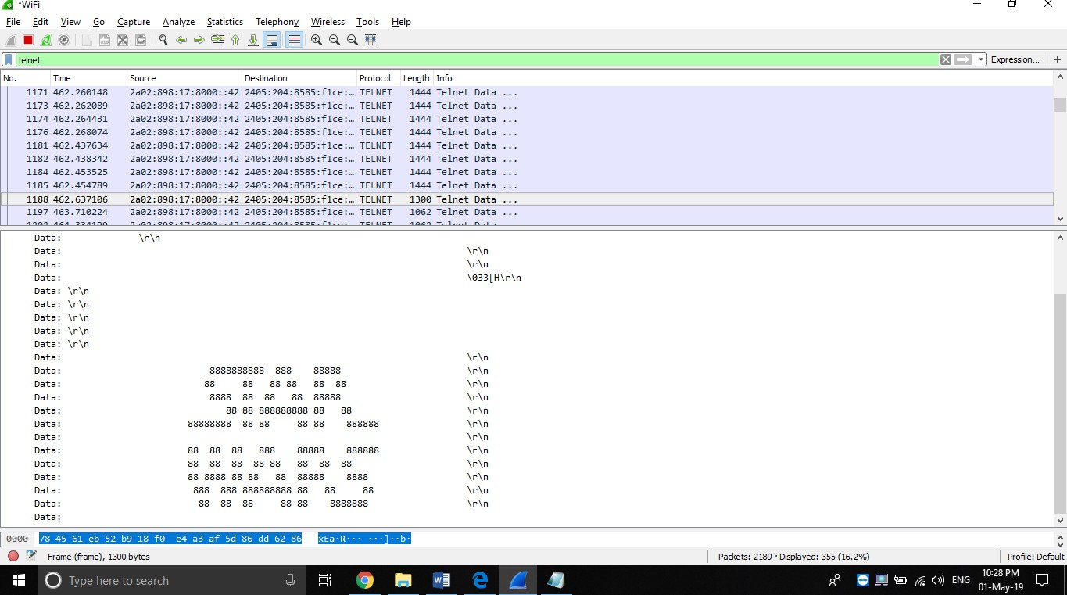

**Prectical no-12**

**AIm: Capture the following traffic types and Interpret/ Analyze the corresponding header and payload: Ethernet and ARP.**

**ARP:**

Address Resolution Protocol (ARP) is a predominant protocol for finding a host’s hardware address when only its network layer address is known.



**HARDWARE TYPE: -** Each data link layer protocol is assigned a number used in this field. For Ethernet it is 1.

**PROTOCOL TYPE: -** Each protocol is assigned a number used in this field. For example, IPv4 is 0x0800. **HARDWARE LENGTH: -** Length in bytes of a hardware address. Ethernet addresses are 6 bytes long. **PROTOCOL LENGTH: -** Length in bytes of a logical address. IPv4 addresses are 4 bytes long.

**OPERATION: -** It specifies the operation the sender is performing: 1 for request, and 2 for reply. There are actually four types of ARP messages that may be sent by the ARP protocol. These are identified by four values in the “operation” field of an ARP message. The types of message are:-

1. ARP request
2. ARP reply
3. RARP request
4. RARP reply

**SENDER HARDWARE ADDRESS**: - Hardware address of the sender.

**SENDER PROTOCOL ADDRESS**: - Protocol address of the sender.

**TARGET HARDWARE ADDRESS**: - Hardware address of the intended receiver. This field is zero on request.

**TARGET PROTOCOL ADDRESS**: - Protocol address of the intended receiver.

**Ethernet:-**

An Ethernet frame is made up of five fields: the Destination and the Source MAC address field, the Ether type field that contains some control information, a Payload field, and a trailing Frame Check Sequence field that holds a checksum for the frame. The Ethernet frame starts with preamble and start frame delimiter, followed by an Ethernet header containing MAC address of source and destination devices.



**Preamble: –** Ethernet frame starts with 7-Bytes Preamble. This is pattern of alternative 0’s and 1’s which indicates starting of the frame and allow sender and receiver to establish bit synchronization. Initially, PRE (Preamble) was introduced to allow for the loss of few bits due to signal delays.

**Start of frame delimiter (SFD): –** This is a 1-Byte field which is always set to 10101011. SFD indicates that upcoming bits are starting of frame, which is destination address. Sometimes SFD is considered the part of PRE, this is the reason Preamble is described as 8 Bytes in many places.

**Destination Address: –** This is 6-Byte field which contains the MAC address of machine for which data is destined.

**Source Address: –** This is a 6-Byte field which contains the MAC address of source machine. As Source Address is always an individual address (Unicast), the least significant bit of first byte is always 0.

**Length: –** Length is a 2-Byte field, which indicates the length of entire Ethernet frame. This 16-bit field can hold the length value between 0 and 65534, but length cannot be larger than 1500 because of some own limitations of Ethernet.

**Data: –** This is the place where actual data is inserted, also known as **Payload**. Both IP header and data will be inserted here, if Internet Protocol is used over Ethernet. The maximum data present may be as long as 1500 Bytes. In case data length is less than minimum length i.e. 46 bytes, then padding 0’s is added to meet the minimum possible length.

**Cyclic Redundancy Check (CRC): –** CRC is 4 Byte field. This field contains 32-bits hash code of data, which is generated over Destination Address, Source Address, Length and Data field. If the checksum computed by destination is not same as sent checksum value, data received is corrupted.



**Prectical no-13**

**AIM: Objective: Capture Wi-Fi and Bluetooth Traffic and Interpret/ Analyze the corresponding header and payload using Wireless Traffic Sniffing tools like Wireshark-USB/AirCrackng/ Kismet, etc.**

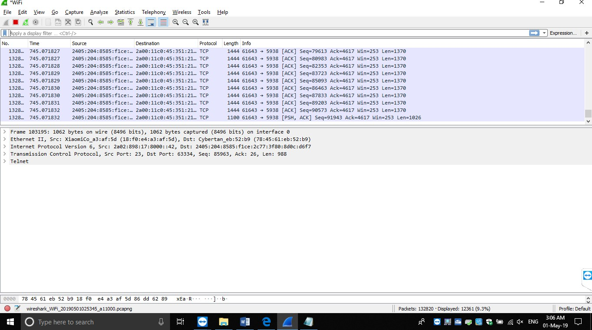Wifi

**Prectical no-14**

**AIM: Analyze Email Traffic: Normal POP Communications, POP Problems, Dissect the POP Packet Structure, Filter on POP Traffic, Normal SMTP Communications, SMTP Problems, Dissect the SMTP Packet Structure, Filter on SMTP Traffic.**

**POP**: Post Office Protocol (POP) is an application layer protocol used by email systems to retrieve mail from email servers. The email client uses POP commands such as LOGIN, LIST, RETR, DELE, QUIT to access and manipulate (retrieve or delete) the email from the server. POP3 uses TCP port 110 and wipes the mail from the server once it is downloaded to the local client.

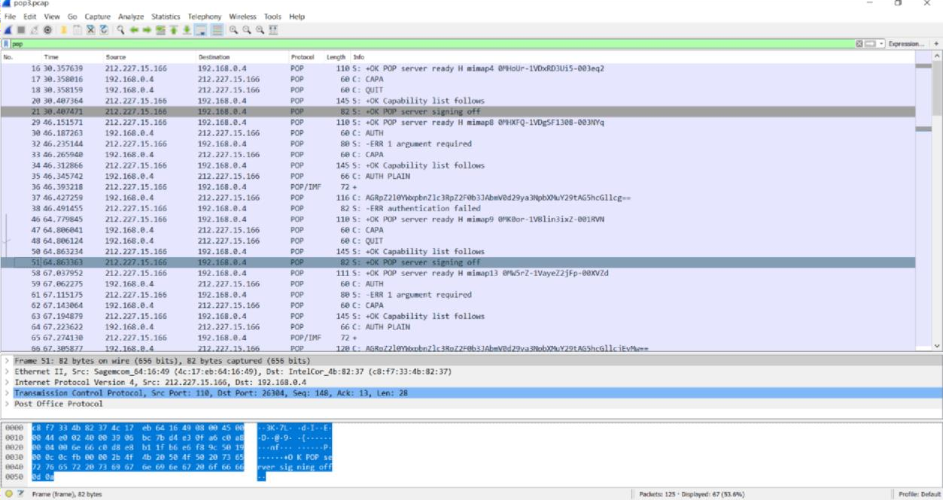**POP communications**

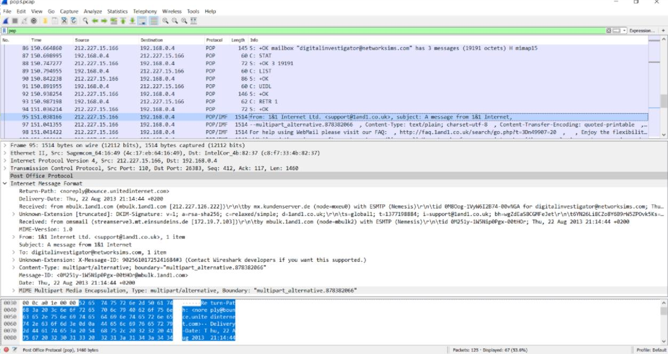**POP packet structure**

## Filter on POP Traffic

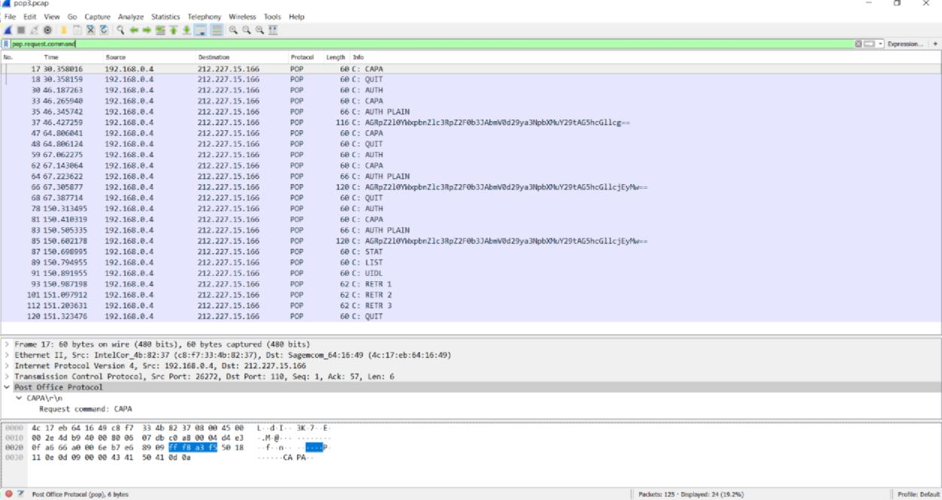

**Flow graph of POP**

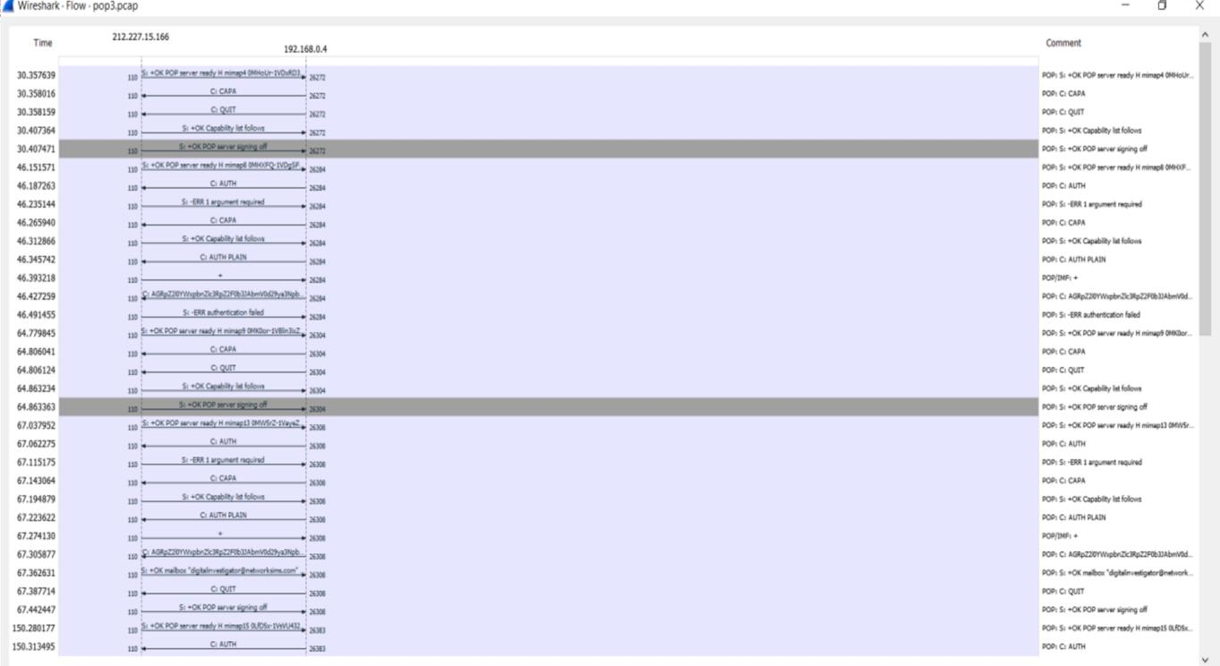

## IO graph of POP

## 

**SMTP**: **Simple Mail Transfer Protocol** (**SMTP**) is an application layer protocol that is used to send email from the client to the mail server. When the sender and receiver are in different email domains, SMTP helps to exchange the mail between servers in different domains. It uses TCP port 25:

## SMTP Communication

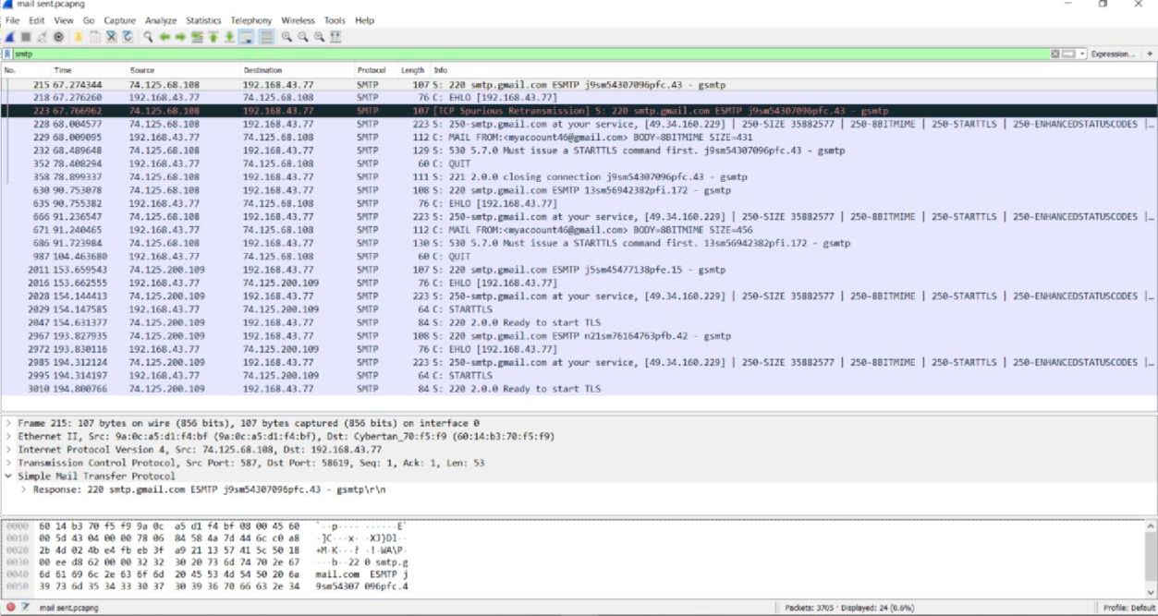

**Filter on SMTP Traffic**

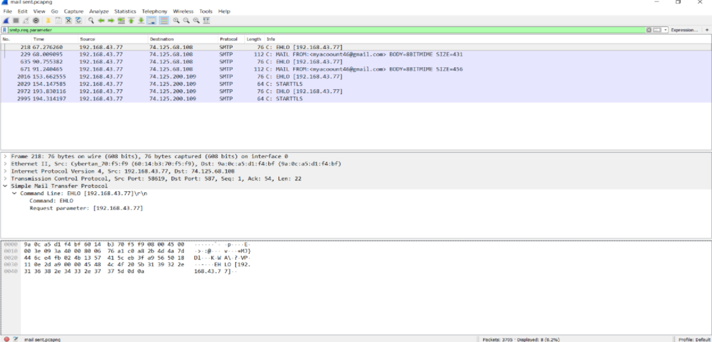

## Flow graph of SMTP

**IO graph of SMTP**

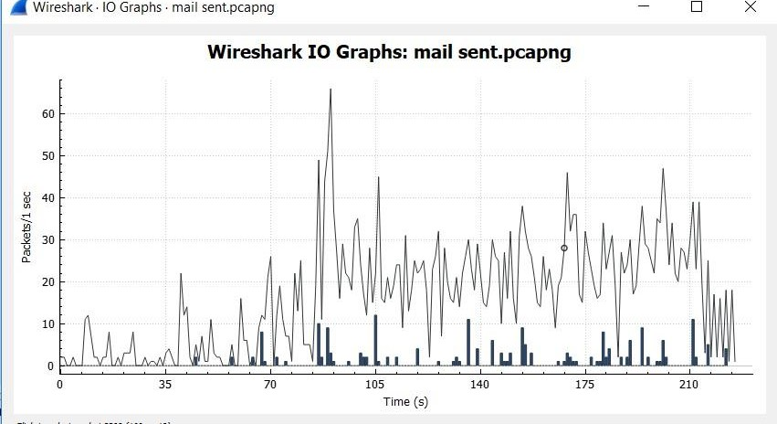

**Prectical no-15**

**Aim: Analyze IEEE 802.11 (WLAN): Wireless LANs (WLANs) Traffic, Signal Strength and Interference, Capture WLAN Traffic, 802.11 Traffic Basics like Data Frame, Normal 802.11 Communications**

## 802.11 Communication

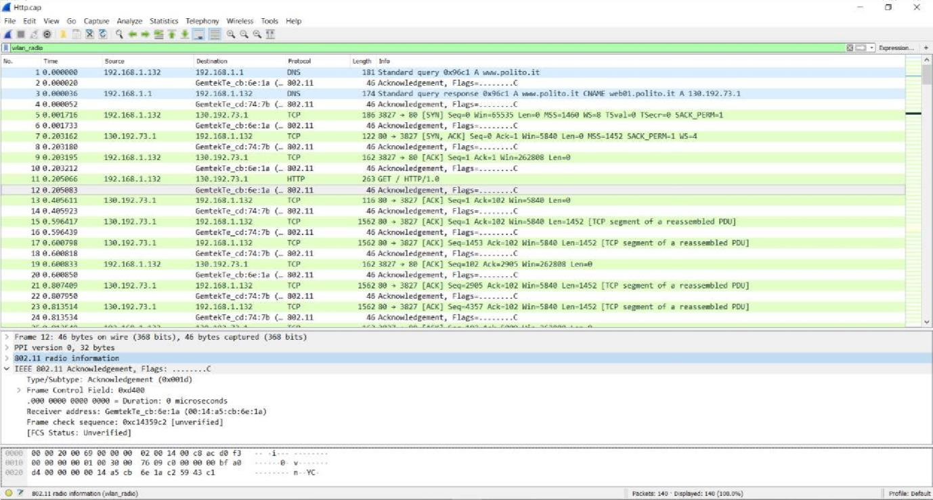**Filter on 802.11 Traffic**

## Flow graph of 802.11

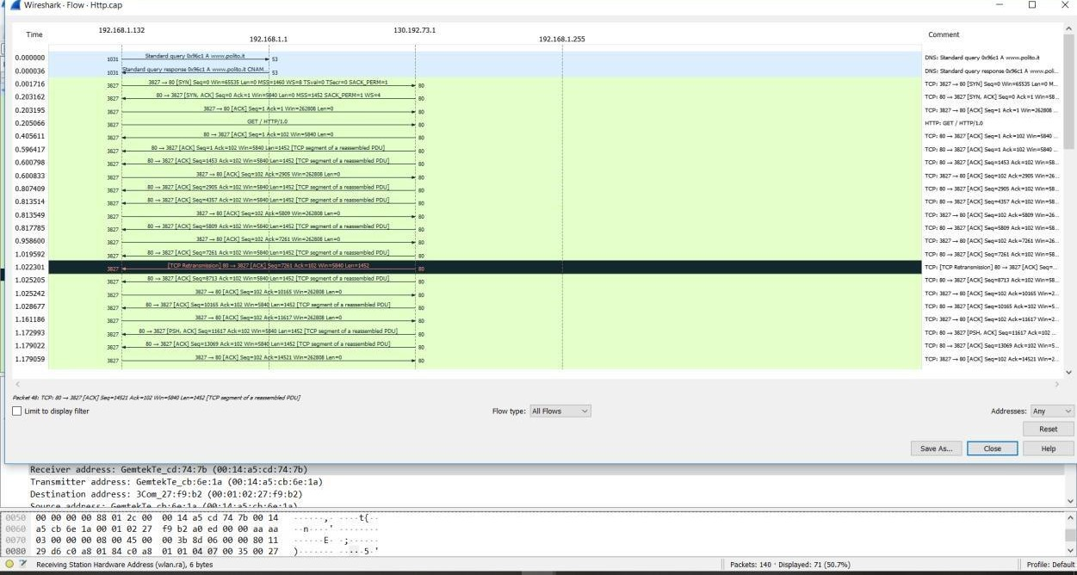

**IO graph of 802.11**

